**Experiment-1**

***Aim:*** Study of different types of Network cables and practically implement the cross-wired cable and straight through cable using clamping tool***.***

**Apparatus (Components):** RJ-45 connector, Climping Tool, Twisted pair Cable

**Procedure:** To do these practical following steps should be done:

1. Start by stripping off about 2 inches of the plastic jacket off the end of the cable. Be very careful at this point, as to not nick or cut into the wires, which are inside. Doing so could alter the characteristics of your cable, or even worse render is useless. Check the wires, one more time for nicks or cuts.
2. Spread the wires apart, but be sure to hold onto the base of the jacket with your other hand. You do not want the wires to become untwisted down inside the jacket. Category 5 cable must only have 1/2 of an inch of 'untwisted' wire at the end; otherwise it will be 'out of spec'. At this point, you obviously have alot more than 1/2 of an inch of un-twisted wire.
3. You have 2 end jacks, which must be installed on your cable. If you are using a pre-made cable, with one of the ends whacked off, you only have one end to install - the crossed over end. Below are two diagrams, which show how you need to arrange the cables for each type of cable end. Decide at this point which end you are making and examine the associated picture below.

**Diagram shows you how to prepare Cross wired connection**

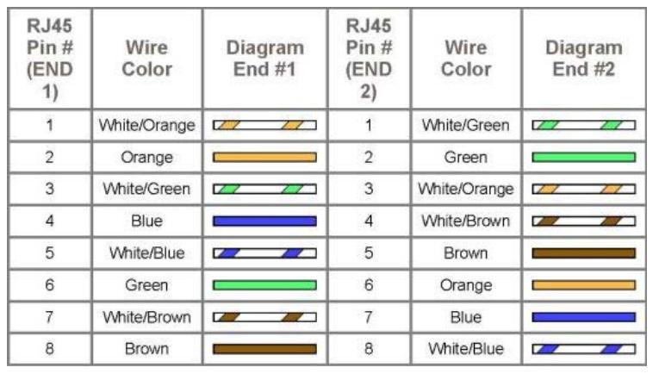

**Diagram shows how to prepare straight through wired connection**

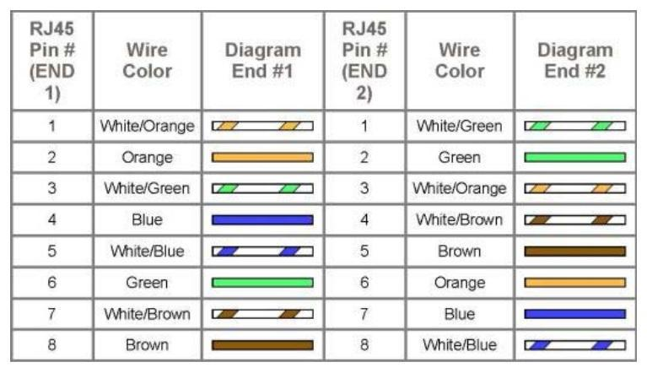

**Different types of Network Cables:**

1. Coaxial Cables;

* Coaxial cable is very commonly used transmission media, for example, TV wire is usually a coaxial cable.
* It contains two conductors parallel to each other.
* It has a higher frequency as compared to Twisted pair cable.
* The inner conductor of the coaxial cable is made up of copper, and the outer conductor is made up of copper mesh. The middle core is made up of non-conductive cover that separates the inner conductor from the outer conductor.
* The middle core is responsible for the data transferring whereas the copper mesh prevents from the **EMI**(Electromagnetic interference).

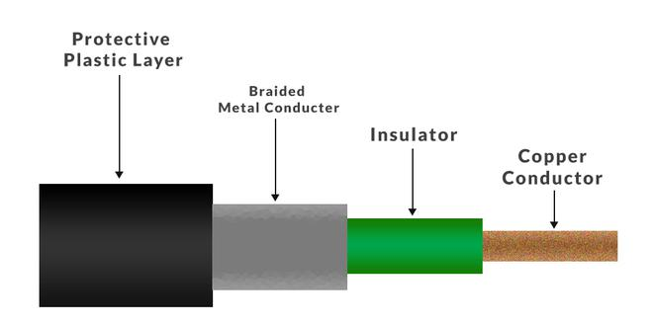 Structure of coaxial cables

1. Twisted Pair Cables

* Twisted pair is a physical media made up of a pair of cables twisted with each other.
* A twisted pair cable is cheap as compared to other transmission media.
* Installation of the twisted pair cable is easy, and it is a lightweight cable.
* The frequency range for twisted pair cable is from 0 to 3.5KHz.
* A twisted pair consists of two insulated copper wires arranged in a regular spiral pattern.
* The degree of reduction in noise interference is determined by the number of turns per foot. Increasing the number of turns per foot decreases noise interference.

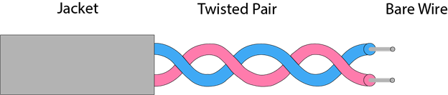

Structure of Twisted Wires

Types of Twisted Wires:

(a)Unshielded Twisted Pair Cables (UTP) :

● These are a pair of two insulated copper wires twisted together without any other insulation or shielding and hence are called unshielded twisted pair cables. They reduce the external interference due to the presence of insulation.

● These cables are cost-effective and easy to install owing to their compact size.

● The connection established using UTP is not secure.

● They are generally used for short-distance transmission of both data and voice.

● These cables have limited bandwidth

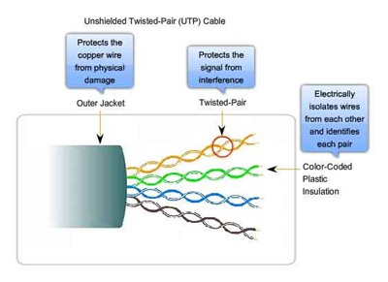

(b) Shielded Twisted Pair Cables (STP) :

● These are the cables that have been twisted together and enclosed in some sort of shield, whether it be foil or mesh. These shields protect the wires from electromagnetic interference.

● They are generally used for long-distance communication and transmission and are installed underground.

● They have a higher bandwidth as compared to UTP.

● These cables are very expensive.

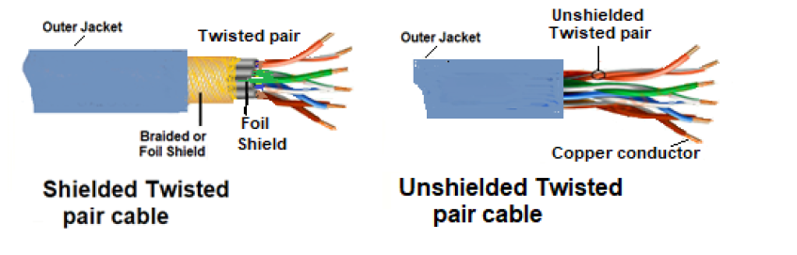

1. Optic Fibre

* Fibre optic cable is a cable that uses electrical signals for communication.
* Fibre optic is a cable that holds the optical fibres coated in plastic that are used to send the data by pulses of light.
* The plastic coating protects the optical fibres from heat, cold, electromagnetic interference from other types of wiring.
* Fibre optics provide faster data transmission than copper wires.

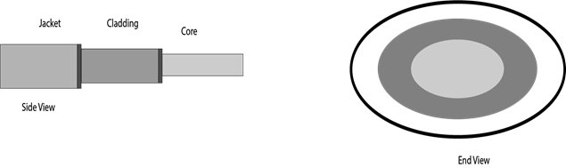

Structural representation of Optic Fibre

**Basic elements of Fibre optic cable:**

* **Core:** The optical fibre consists of a narrow strand of glass or plastic known as a core. A core is a light transmission area of the fibre. The more the area of the core, the more light will be transmitted into the fibre.
* **Cladding:** The concentric layer of glass is known as cladding. The main functionality of the cladding is to provide the lower refractive index at the core interface as to cause the reflection within the core so that the light waves are transmitted through the fibre.
* **Jacket:** The protective coating consisting of plastic is known as a jacket. The main purpose of a jacket is to preserve the fibre strength, absorb shock and extra fibre protection.

1. Crimping Tool:

Cable crimping is a process of joining wires to another metal terminal. When crimping, the terminal will be compressed to connect to the wire conductor.

● An RJ45 crimping tool is a device used in the networking system. It is a used to crimp and terminate RJ45 plugs.

● An RJ45 crimping tool is a special device for the installation of different cabling systems. It usually features a compact design that is practical and easy to use.

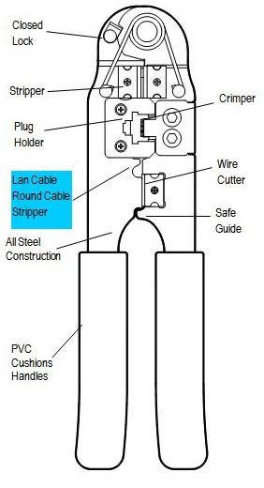● It also provides a solid connection between RJ45 connector to the Ethernet cable.

Diagram of Crimping Tool